**Bug report**

Site: <https://www.pakrailways.gov.pk/>

Bug no 1:

**Bug Report**

Issue: When attempting to update the database with correct login details, the system fails to execute the update operation. It reports that the database is read-only, preventing the update process from completing successfully.

**Steps to Reproduce**:

Navigate to the login page.

Enter the correct login credentials.

Submit the login form.

Observe the error message indicating the database is read-only.

**Expected Behavior**: After entering the correct login details, the system should authenticate the user and update the database accordingly without encountering any read-only restrictions.

**Actual Behavior**: The system fails to update the database, displaying an error message indicating that the database is read-only.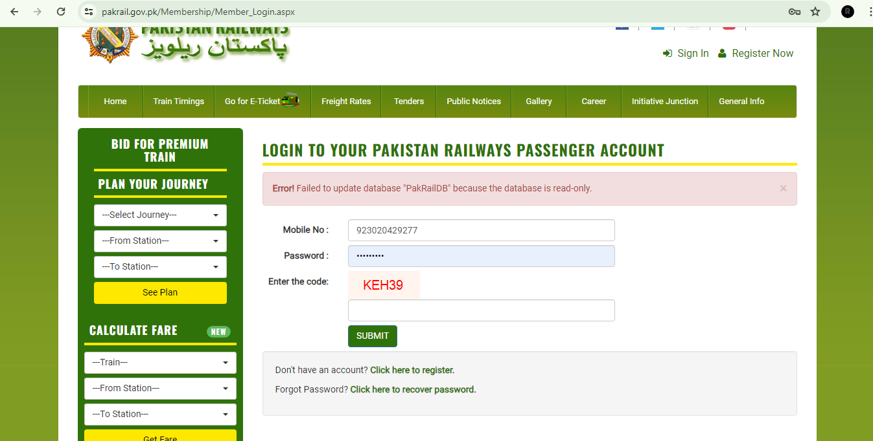

Bug no 2:

**Bug Report**:

**Title**: Unable to Login Despite Correct Captcha Entry

**Description**: Users are encountering an issue where they are unable to login to their accounts even after correctly entering the captcha code. The problem persists despite multiple attempts, indicating a potential bug in the login authentication process. This issue significantly impacts user experience as it prevents access to their accounts despite completing the required verification step. Further investigation is needed to identify and resolve the underlying cause of this login failure.

**Steps to Reproduce**:

Navigate to the login page.

Enter valid login credentials.

Complete the captcha verification by entering the correct code.

Attempt to login.

Observe that despite entering the captcha correctly, the login attempt fails, and users are unable to access their accounts.

**Expected Behavior**: After entering the captcha code correctly, users should be able to successfully login to their accounts.

**Actual Behavior**: Despite entering the captcha code correctly, users are unable to login, and the authentication process fails, denying access to their accounts.

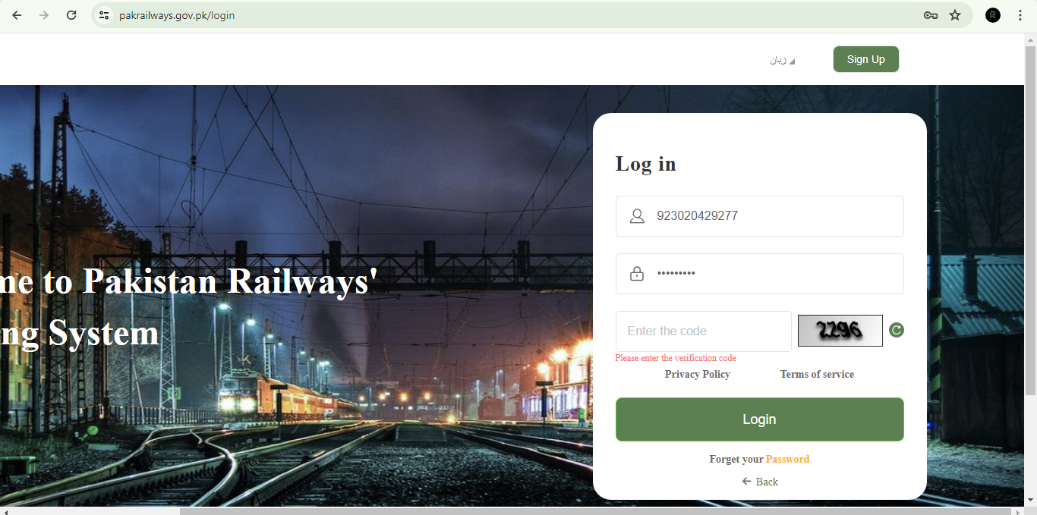

Bug no 3:

**Bug Report**

Title: Session Expiry During Train Booking Validation

**Description**: Users encounter a session expiry error while attempting to validate their train booking details. Despite inputting all required information accurately, users are unable to proceed with the booking process due to the session expiration message. This issue disrupts the booking flow and prevents users from completing their train reservations, leading to potential loss of bookings and frustration among users.

**Steps to Reproduce**:

Navigate to the train booking section of the application.

Input all required booking details, including departure and arrival stations, date, passenger information, and any additional preferences.

Proceed to the validation step to confirm the booking details.

Observe that instead of completing the validation process, users encounter a session expiry error message.

Attempt to refresh the page or repeat the validation step, resulting in the same session expiry message.

**Expected Behavior**: After inputting all required booking details, users should be able to successfully validate their train booking and proceed to the next step of the reservation process without encountering any session expiry errors.

**Actual Behavior**: Despite inputting all necessary information accurately, users are unable to complete the booking validation process due to a session expiry error, preventing them from proceeding with their train reservations.

